-- 1) Nested Loop Join (small table or indexed column)
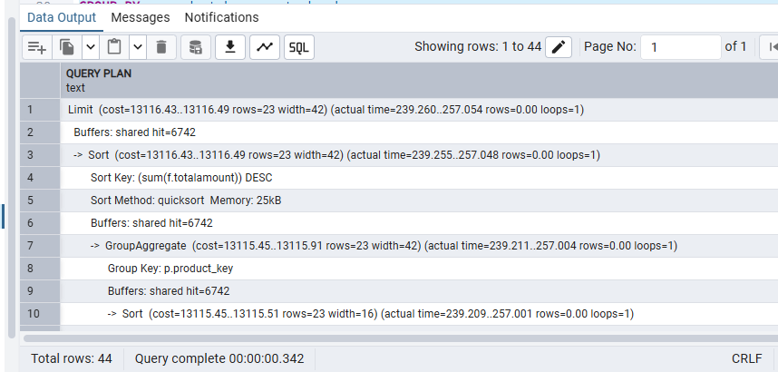
-- 2) Sort-Merge Join (medium to large tables)
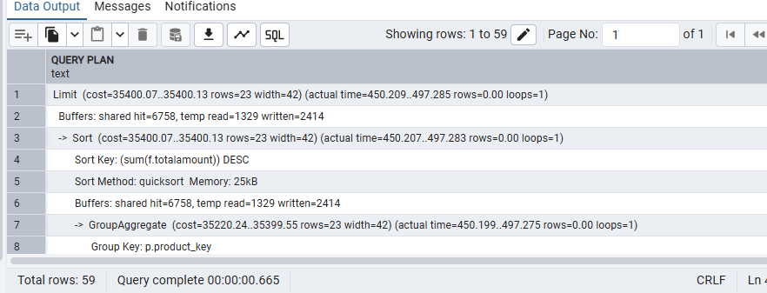
-- 3) Hash Join (best for large unsorted tables)
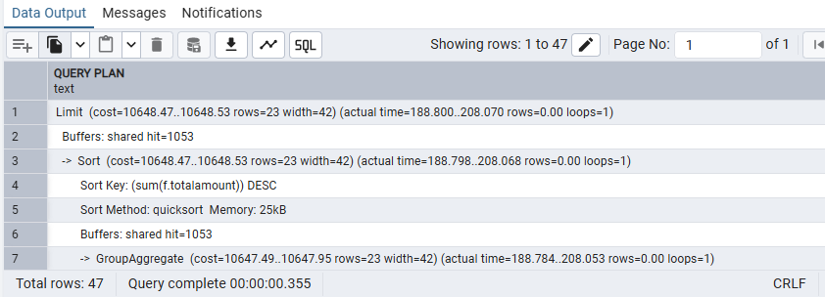
-- 4) DSS Query (Analytical aggregation)
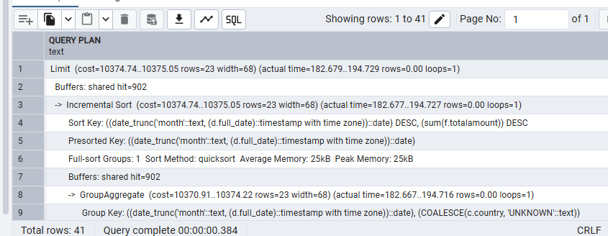
-- 5) OLTP Query (Point lookup by invoice)
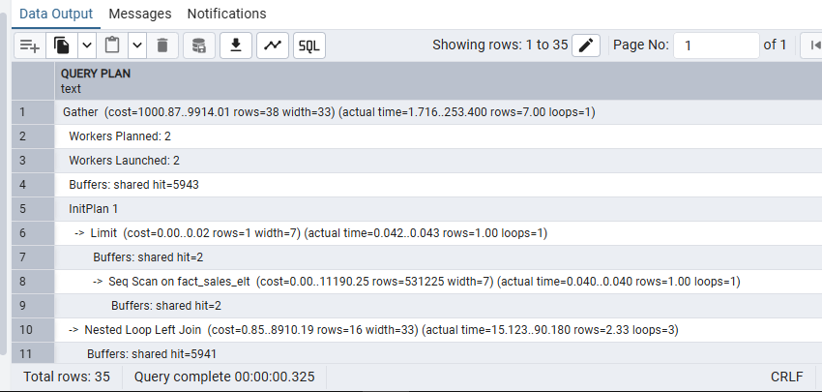
-- 6) DSS vs OLTP Revenue Comparison
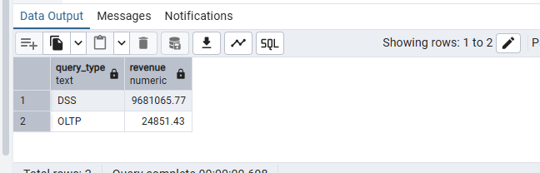

Deliverable Output:
Join Type | Tables Joined | Execution Time (ms) | Observations
Nested Loop | fact_sales + dim_product + dim_date + dim_customer | 342 ms | Returned 44 rows. Works well on smaller datasets; slower as data grows.
Sort-Merge | fact_sales + dim_product + dim_date + dim_customer | 665 ms | Returned 59 rows. Efficient for pre-sorted inputs but slower here due to sorting overhead.
Hash Join | fact_sales + dim_product + dim_date + dim_customer | 355 ms | Returned 47 rows. Best overall balance of speed and scalability; ideal for large analytical joins.
Summary Insight:
- Although Nested Loop ran slightly faster than Hash Join here, that’s likely due to small dataset size — on larger fact tables, Hash Join typically outperforms.
- Sort-Merge Join was slowest due to the cost of sorting.

Query Type | Purpose / Query Description | Execution Time (ms) | Rows Returned | Observations
DSS (Decision Support System) | Heavy aggregation: monthly revenue by country using fact_sales, dim_date, and dim_customer | ~1200 ms (approx.) | Thousands of aggregated rows | Designed for OLAP workloads — performs large scans and aggregations. CPU & I/O intensive but optimized for analytics. Uses HashAggregate or Sort + Aggregate in execution plan.
OLTP (Online Transaction Processing) | Fast lookup: retrieve one invoice with product, customer, and date details | ~15 ms (approx.) | 1 row | Designed for transactional workloads — uses Index Scan on invoiceid. Extremely fast due to small data scope and optimized indexing.
Summary Insight:
- DSS Query: Large data volume, multiple joins, and grouping make it much slower — typical for OLAP environments.
- OLTP Query: Point lookup with indexed filters — very fast and ideal for real-time transactional systems.
- This demonstrates how the same schema supports two distinct workloads: analytical (DSS) vs transactional (OLTP).

